They Will All Be Taught By God
September 22, 2016

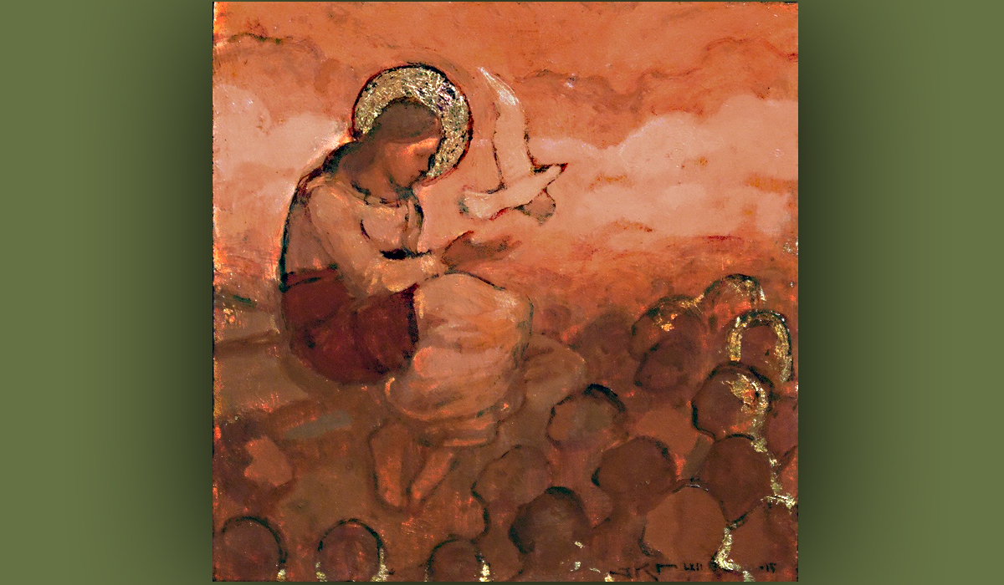
The Lord bless you, dear Heartdwellers.

The Lord had an interesting lesson today. He began immediately when I came to sit down and listen for the message.

He said, “I want to talk with you about obedience. My Children, My Bride, what good does it do you to hear My words, knowing My intentions for you and then not obeying? It is not of any benefit to you but is most surely a detriment. It is damaging to know the will of God which in itself is one GREAT grace and then not follow through with it.

“This channel is like a classroom. A great classroom. Each day I bring you a fresh lesson for you are in the school of holiness. The whole curriculum is tailored to prepare you for the day I take you to Myself. All the angels in your life are working in cooperation with My Spirit and arranging your lessons for the day. That is why you so often find yourselves getting the answer you asked Me for on this channel. You are in a great classroom, and I am your teacher. Clare is but a secretary passing on My message. Yet she has My heart on many things, not just the message of the day.

“So in a classroom, you come to be taught and you do your assignments so you can pass your tests and get an A, as well as graduating with honors. Yes, this is an honor class for those who have chosen to give Me their all. If you do your homework, you will pass in flying colors. So, I am asking you, My Children, to pay close attention to what I tell you in these lessons and do your homework. Follow these instructions.

“By the way, when I talk about obedience, you are never required to do anything against your conscience or your faith, to be obedient. There are times when you cannot obey those in your lives who you normally would. For instance, normally you would obey the custom’s rules when you are entering a country, but if Bibles are illegal, you are not required to obey the laws of men. You are fully in your rights to smuggle them in, for this is your obedience to Me.

“If your spouse tries to interfere with your faith and you’ve done everything in your power to appease them, but they are still striking at the heart of your faith, you are not required to obey. Even as the Scriptures say, “Wives obey your husbands, Wives, submit yourselves to your own husbands as you do to the Lord.” Ephesians 5 In another instance, there are some among you who have been called to prepare a refuge for the times ahead, so for you, these lessons about not preparing do not apply.

“But getting back to the point at hand. I only ask you to do or not to do something because it will result in good fruit in your life. You dwell in the vine…but if you cast away the vine to find another dwelling, you will not bring forth good fruit.

“I am the vine and you are the branches. The one who remains in Me, and I in him, will bear much fruit. For apart from Me you can do nothing.” John 15:5

“So, when I bring you these directives it is because I know they will result in good fruit in your lives.”

And at that point, I was just aching to say something. I said: Lord, may I say something?

He replied, “Go ahead.”

Heartdwellers, I have to tell you, I am merely doing my little part in bringing to you what the Lord puts on my heart. If He does not tell me about some event, I do not know anything about it. There may be warning spread far and wide over the Internet about this or that…asteroids, comets, earthquakes, tsunami's. But if He does not bring that to me, I have no knowledge beyond what He has given me, and I have learned to trust His judgment on what to give and what to withhold.

He is working with Heartdwellers in a certain way. He has things in mind for us, goals He wishes for us to accomplish. This is His will for this channel. He has anointed other channels for other things and each has a part in these end times, to prepare the Bride and His people. Some souls are here because God sent them; others are in other places where God has placed them. This channel is very focused in a peculiar way for those He sent here.

So, I must stick to His agenda for you. I cannot follow this one and that one and try to discern if what they are saying is true. I have no ability to do that and it’s not my mandate. So, if events occur that He has NOT told me of, it is for a good reason that I was not told. Or if someone brings me a word they believe should be shared on this channel and it doesn’t pass my discernment, I will not share it. I can be fallible, of course!!! But I must be obedient to the known will of God and He’s made His lessons so clear to me, I will not depart from them.

Jesus continued, “Clare, there is no reason for you to apologize, you are doing as I have asked. In all things I am leading you My way. And what I do not tell you, you have no knowledge of, and that is as it should be.

“And for all of you, My Dear ones, test the spirits and see if they be of God. When you peruse channels for the latest, see how much time you gave to that practice. Note how you feel at the end: are you satisfied, frustrated or disappointed? Confused? Are they actions that you're going to take next, motivated by fear, by love, by peace? All these things should be examined very closely, to see what the source is of what you listen to, lest you be led astray. Does it contradict your current direction in your life? Or does it support it? Do you feel like you've lost Me somewhere along the line and you're supposed to be going in a totally different direction? Or do you have peace? Because the enemy will use these things to cause severe confusion and to stop what you're doing, if it's anointed. These are all things you should examine very closely and know that the devil will continually try to divert your attention from your anointing and your calling. So be on the lookout for that. And measure everything you do to make sure that it's consistent with what you KNOW I've told you to do in your heart. Judge the fruit and make a decision based on that. This is how I have taught you and it applies here as well.

“I love you, My dear ones. I withhold no good thing from you. I have a purpose for your life, and it pleases Me greatly when you follow the course I have laid out for you. How will you know this? By the fruit, of course."

And that was the end of His message.

Well, I wanted to share something very interesting with you. As I was giving you this message, Ezekiel overheard it and he was having his communion service. He opened to Acts 20:28. And this is what it had to say:

“Keep watch over yourselves and all the flock of which the Holy Spirit has made you overseers. Be shepherds of the church of God, which he bought with his own blood. I know that after I leave, savage wolves will come in among you and will not spare the flock. Even from your own number men will arise and distort the truth in order to draw away disciples after them. So be on your guard! Remember that for three years I never stopped warning each of you night and day. Acts 20:28-31”

I thought that was very interesting, because I know that these two messages are going to be contested by some people. And I understand why. But I just have to be obedient. You are the ones that must discern what is from God and what is not.

And I have an update for you. The Lord has stated clearly how my day should begin and what comes first. I’ve been doing that for three days now. I must say, the fruit is beyond what I expected and I am deeply satisfied with what I accomplish each day. The sink is full of dishes and the floors need sweeping…and I have planned time for that later. But I know my day is ordered by the Lord and I can’t describe to you the great peace that has resulted from my obedience.

May He order your days as well.

The Lord bless you all, dear Heartdwellers. And thank you for your prayers and support. We so appreciate you being on our Channel.

